Chapter 0: Everyday Works of A Data Engineer
Abstract: Data Engineers build systems to collect, connect different sources, process data, automate the process, and deliver value through technical solutions. They create the foundation for all data work. Their expertise centers on building reliable pipelines, enabling all downstream data activities. Their roles includes
- Designing data infrastructure and architecture
- Creating and maintaining data pipelines
- Ensuring data quality and availability
Before a data scientist even touches the data, a data engineering team has already built a pipeline that turns messy, raw inputs into something reliable and consistent. Think of it less as a one-time cleanup and more as a continuously running system.
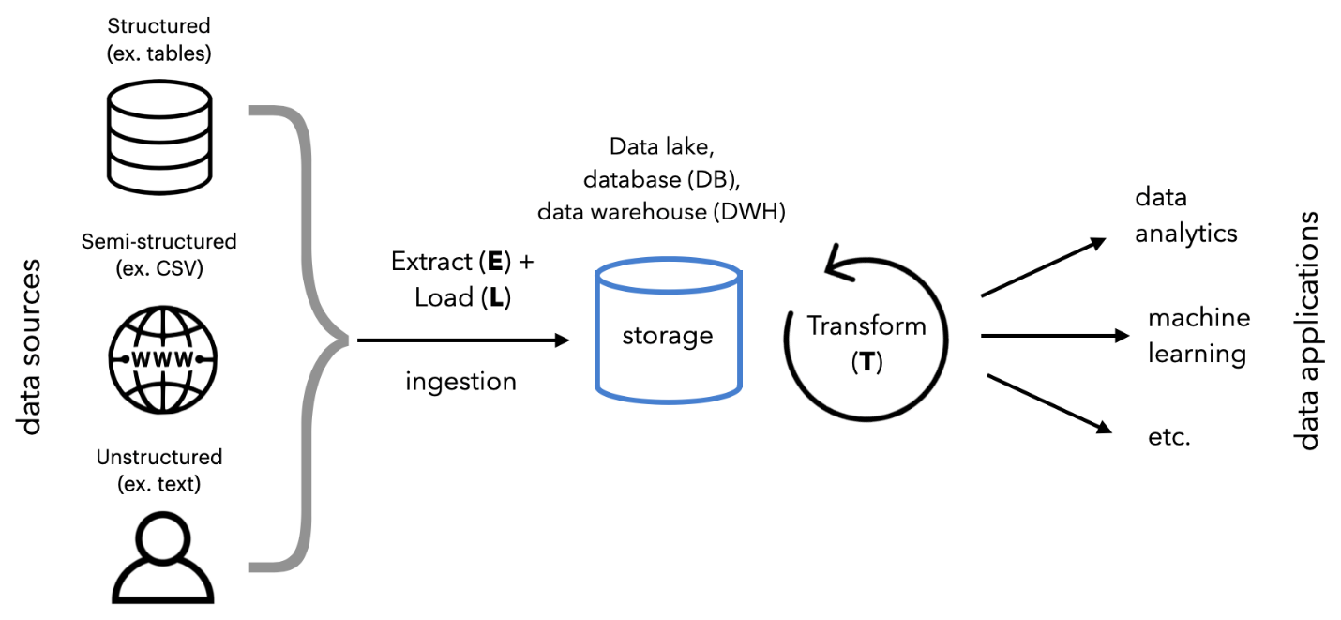
At a high level, data engineers design automated pipelines (often called ETL or ELT as an abbrevation for Extract - Transform - Load) that handle data from ingestion to storage. The goal isn’t just cleaning once, but enforcing consistency every time new data arrives.
Ingestion with validation gates: Data flows in from APIs, databases, logs, or files. Right at this stage, engineers add validation rules (e.g., checking types, required fields, formats, and ranges). Tools like Apache Kafka or Apache NiFi are often used to stream and control incoming data. Bad records can be rejected, quarantined, or flagged immediately instead of polluting the system.
Schema enforcement and versioning: To keep things consistent, engineers define strict schemas (column names, data types, constraints). Systems like Apache Avro or Google BigQuery help enforce structure. If a data source suddenly changes format, the pipeline detects it instead of silently breaking downstream models.
Automated cleaning transformations: Cleaning rules are encoded into transformation steps
- Standardizing formats (dates, currencies, text casing)
- Handling missing values (impute, drop, or flag)
- Deduplicating records
- Normalizing inconsistent categories
These transformations run automatically in batch or streaming jobs using frameworks like Apache Spark or dbt.
Data quality checks (continuous testing): Engineers treat data like code getting tested. Tools like Great Expectations define expectations (e.g., “no nulls in user_id,” “values must be within range”). Pipelines fail or alert when expectations aren’t met, preventing bad data from propagating.
Centralized, curated storage layers: Cleaned data is stored in structured layers (often called bronze/silver/gold architecture)
- Raw (unchanged data)
- Cleaned (standardized, validated)
- Curated (business-ready datasets)
Warehouses or lakes like Snowflake or Amazon Redshift ensure consistency and accessibility.
Orchestration and monitoring: All of this is scheduled and monitored using orchestration tools like Apache Airflow. If something fails (for instance, a schema mismatch or spike in missing data), the system alerts engineers immediately.
Example (CSV Databases):
CSVs → (code/scripts doing cleaning & transformation) → PostgreSQL → Data Science work
1. Extract: You scrape or collect a bunch of CSV files from random websites. This is your raw, messy input.
2. Transform: This is where the actual “data cleaning” happens:
- Parsing CSVs
- Fixing formats (dates, numbers)
- Handling missing values
- Deduplicating
- Validating schemas
This step is typically done with scripts or tools (Python, Apache Spark, or even SQL transformations).
3. Load: The cleaned data is then inserted into PostgreSQL.
Notes: This process can also be done by using ELT, instead of ETL.
- Load raw CSVs into PostgreSQL first
- Then transform them inside the database using SQL or tools like dbt
Comparison between traditional ETL vs. modern ETL / ELT
Aspect | Traditional ETL | Modern ETL / ELT stack
Core flow | CSV → Python → PostgreSQL | Sources → Data Lake → Transform → Warehouse
Data sources | Mostly files (CSV, scraped data) | Files, APIs, databases, streams
Storage layer | Directly into PostgreSQL | Data lake like Amazon S3 / Google Cloud Storage
Transformation | Python scripts (pandas, custom logic) | Distributed or SQL-based (Apache Spark, dbt)
Processing scale | Single machine | Distributed across clusters
Loading strategy | ETL (Extract, Transform, Load) | ELT (load first, transform later)
Data volume handling | MB → low GB | GB → TB → PB
Performance bottleneck | CPU / memory of one machine | Cluster size / distributed compute
Reusability | Low (scripts tightly coupled) | High (modular pipelines, reusable models)
Orchestration | Cron jobs / manual runs | Workflow tools (e.g., Airflow)
Data modeling | Done during load | Done after load in warehouse
Schema flexibility | Rigid upfront | Flexible (schema-on-road in lake)
Failure handling | Manual debugging | Built-in retries, logging, monitoring
Cost model | Cheap at small scale | Pay-as-you-scale (storage + compute seperated)
Analytics layer | Same DB handles everything | Dedicated warehouse like Amazon Redshift
Use case fit | Small projects, prototypes | Production systems, large-scale analytics
Notes: Modern stacks do not replace current skills, but reposition those:
- Python data cleaning → becomes Spark jobs or dbt models
- PostgreSQL knowledge → transfers directly to warehouses
- Pipeline logic → move into orchestrators.
Chapter 1: Introduction To Airflow
What is Airflow?
Airflow is an open-source framework which can be used as an orchestrator.
Example:
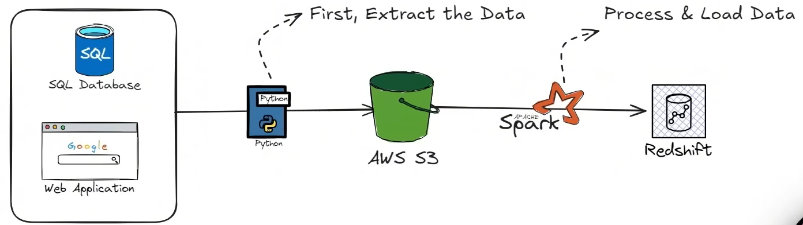
What can Airflow actually do?
- Orchestrates workflows (DAGs)
  - Directed Acyclic Graphs – Each DAG is a pipeline of tasks with dependencies, Airflow ensures the workflow runs sequentially and only when conditions are met.
    - Example: Extract data → Transform it → Load into database → Send report
- Schedules jobs
- Automates data pipelines
- Handle dependencies and retries
- Monitoring & logging: Web-based inspection (See task status, view logs, debug pipelines)
- Scales execution: Run tasks in parallel and distribute work across multiple workers (Kafka, Celery, Kubernetes, etc.)
What Airflow is not?
- Airflow is not a DATA PROCESSING framework.
- Airflow is not a REAL-TIME PROCESSING framework.
- Airflow is not an ETL framework
Example:
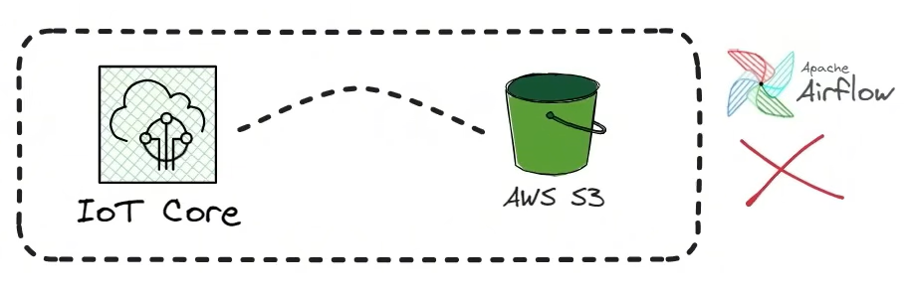
Devices send events to AWS IoT Core, then data lands in Amazon S3. This time Apache Airflow is used to run DAG every 1 minute to:
- Check S3 for new files
- Read data
- Process / aggregate
- Push results downstream
In the long run, this practice will lead to hidden latency (delivery – scheduler delay, task queueing + startup time, file listing + read time) 2 – 5+ minutes latency and event-by-event processing loss.
Why not script?
Simple Workflow: Both Airflow & Python-made scripts can excel
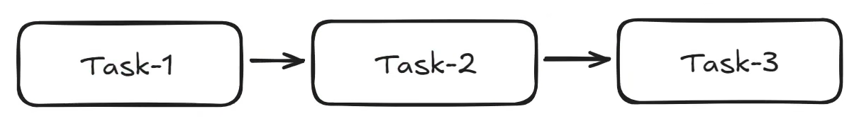
Complex Workflow + State: Airflow beats
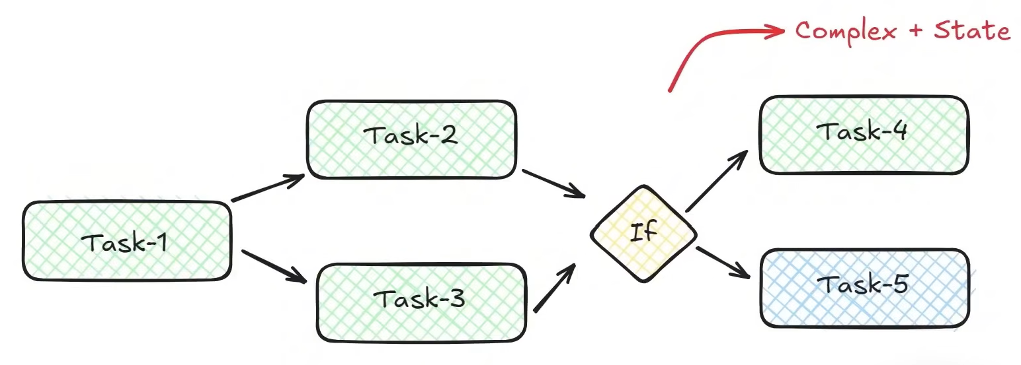
Failed Scenario: One of the parallel tasks fails to perform, the If branch will be skipped, thus the process stops.
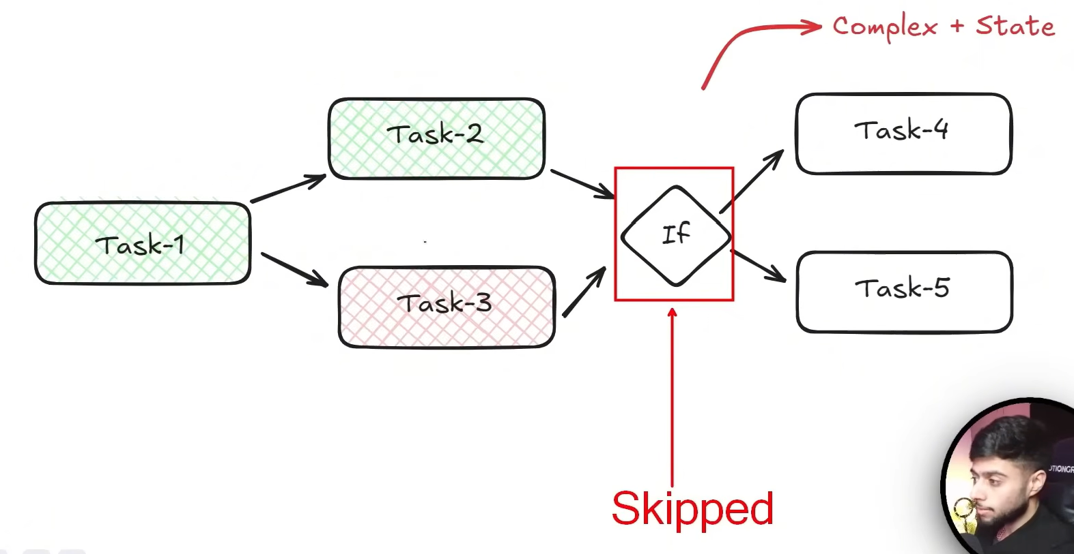
Core Components of Airflow
- Metadata DB
  - Metadata – data about data
    - E.g: sales_2026.csv → date, product, amount | 2026-01-01, shoes, 100. The metadata could be
      - File name: sales_2026.csv
      - Created date: 2026-01-02
      - Schema: (date: string, product: string, amount: integer)
      - Source: "E-commerce system"
      - Owner: "Data team"
  - Airflow needs to store all the metadata about the DAGs. For instance, DAG runs, schedule, status, task instance, etc.
- DAG File Processor: A DAG processor will go to your DAGs folder, parse it and store the serialized DAG {“xyz”: “abc”} into the DB
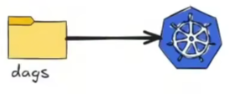
- API Server
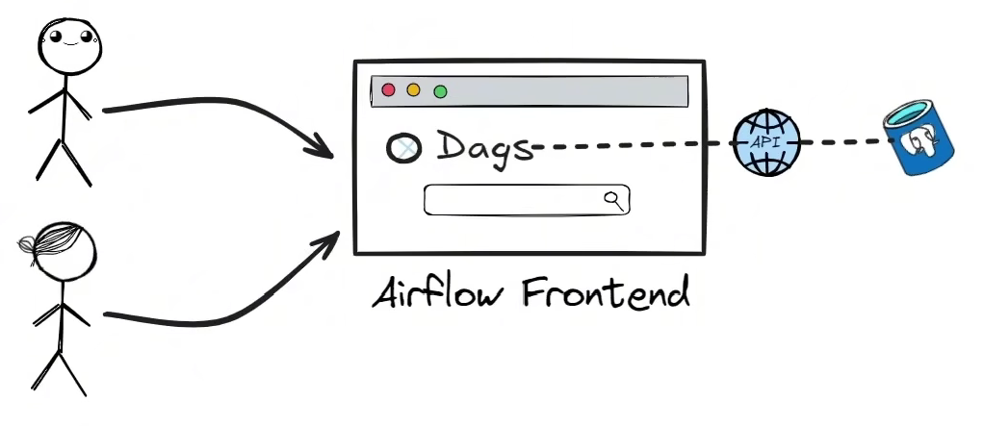
- Scheduler: Responsible for WHAT & WHEN tasks need to be executed
- Executor: Decides the HOW & WHERE tasks need to be run.
- Workers: The real layer for execution
- Queue

- Triggerer
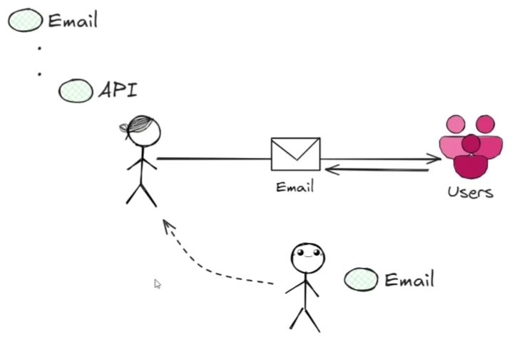
Airflow Architecture
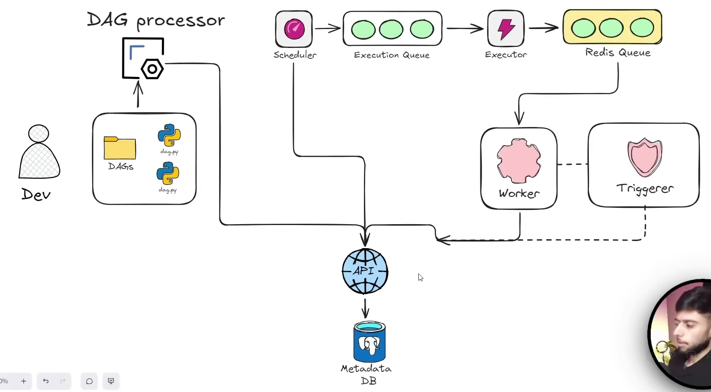
Core Concepts Of Airflow
- DAG – Directed Acyclic Graphs
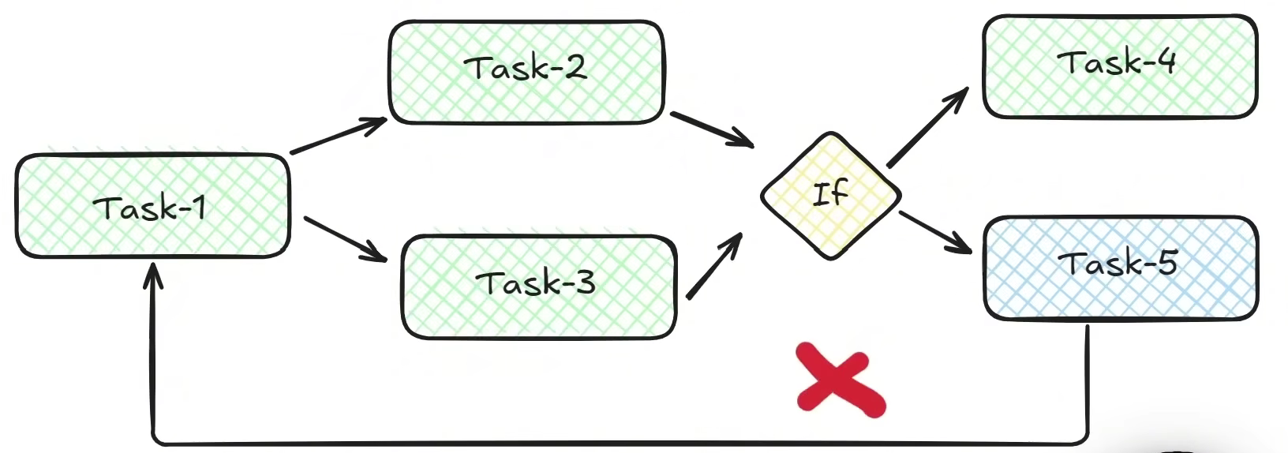
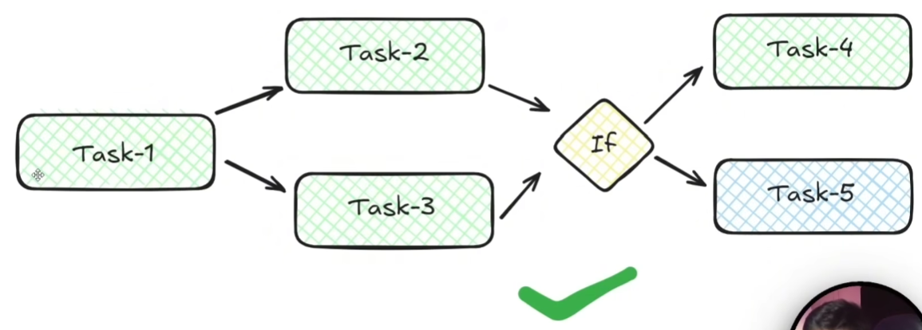
- Task Instance – It’s just a single unit of work
- Operator - It’s the pre-built template for our tasks. It’s basically tells Airflow what of type task we are running.
Chapter 2: Linear DAG, Parsing & Versioning
- How DAGs are synced?
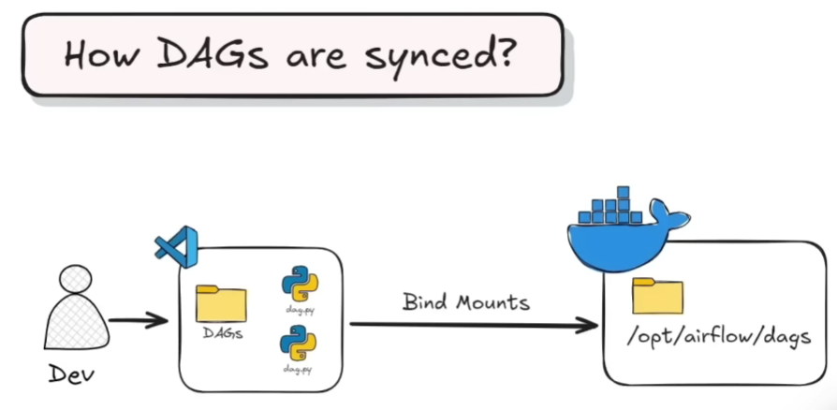
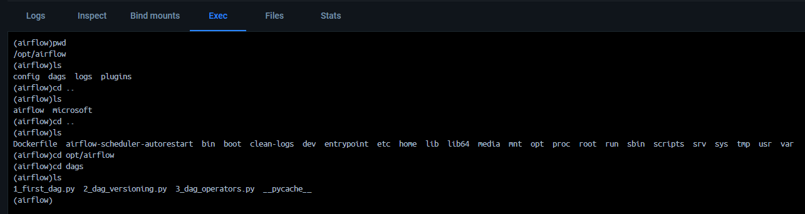
- Implementation
Preliminaries:
- .venv/Scripts/Activate
- docker compose up -d (Open)
- docker exec -it airflow-postgres-1 psql -U airflow -d airflow
- docker compose down (Close)
Implementation (Task 1 → Task 2 → Task 3):
Notes: DAGs are versioned by their code (Git). Each run is tied to
- A specific execution date / logical date
- The DAG structure at the time it ran (does not always snapshot the code per run)
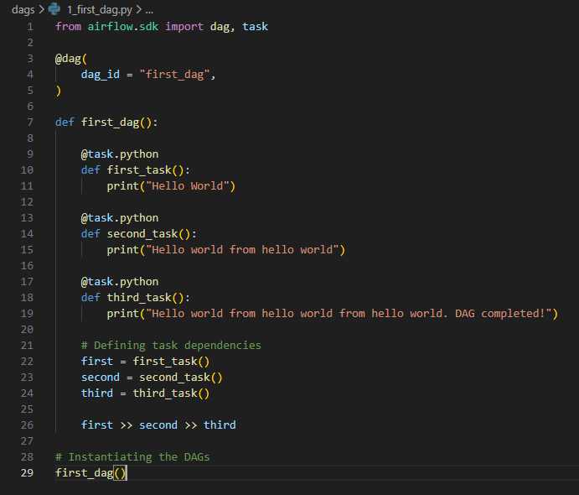
Results:
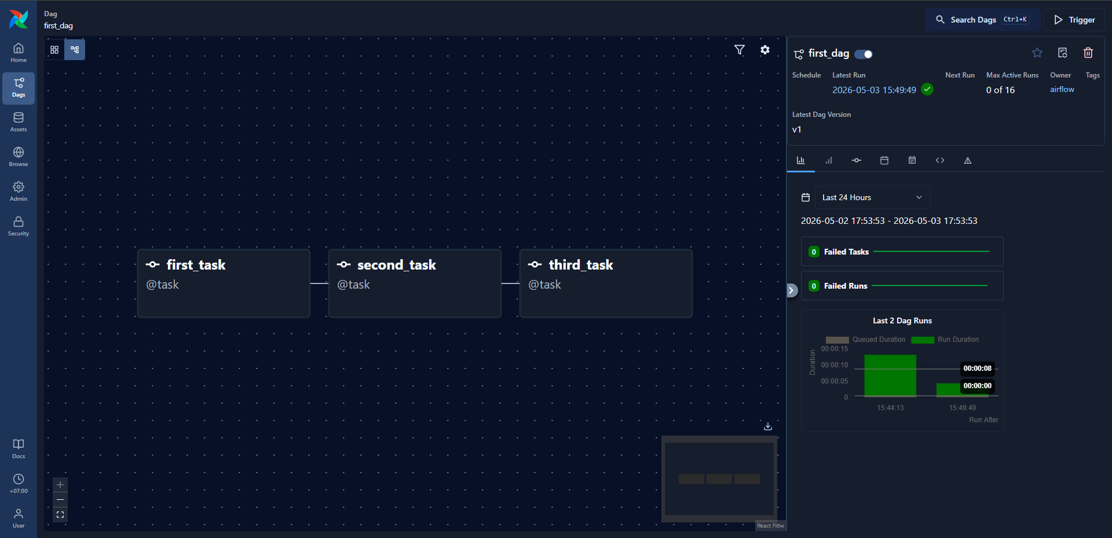
Chapter 3: Operators & DAGs Syncing
Definition: Operators are the building blocks of a workflow (DAG). Each operator represents a single task (e.g., running a script, querying a database, or sending an email).
Bash Operators: A specific operator used to run shell commands, which lets you execute any command you’d normally run in a terminal.
- Running a .sh script
- Using echo, cp, wget, etc.
- Triggering CLI tools
E.g:
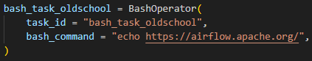
Two Ways to Declare Tasks in Airflow
- Decorator-based (TaskFlow API)
This is the modern, cleaner approach using Python decorators:
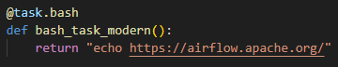
Here you can define the use of task by using @task.bash, rather than @task. This will return a bash command string.
- Direct Operator Instantiation
This is the older, more explicit method:
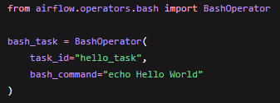
Key Differences
Decorator style:
- More Pythonic and concise
- Easier data passing between tasks
- Preferred in newer DAGs
Direct operator style:
- More explicit and flexible
- Still widely used, especially in legacy DAGs
Chapter 4: XCOMs (Cross-Communications)
Definition: XCOMs are a built-in mechanism that let tasks share small pieces of data with each other. Since Airflow tasks are designed to be isolated, XCOMs act as a lightweight messaging system between them.
What are they doing?
The store key – value pairs in Airflow’s metadata database
Used for passing small data (not large datasets)
Typically accessed via:
- xcom_push() → send data
- xcom_pull() → retrieve data
Two common ways to set up communication
- Return values
If you are using the TaskFlow API (@task decorator), whatever a task returns is automatically pushed to XCOM. It’s considered to be the cleanest and most modern approach.
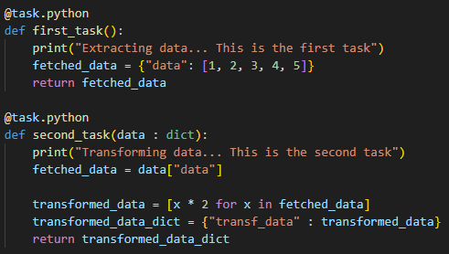
What happens:
- extract() returns a value
- Airflow automatically stores it in XCom
- That value is passed downstream as an argument
- Using kwargs
In traditional operators (like PythonOperator), you use **kwargs to interact with XCOM manually via the task instance (ti). This method is more flexible, but also more verbose
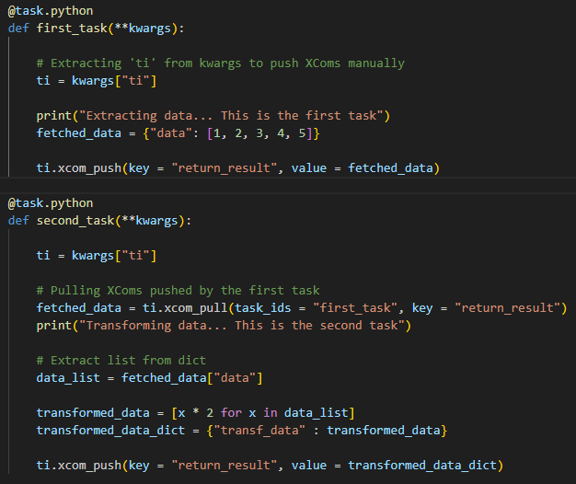
What happens:
- You explicitly push data using xcom_push
- You explicitly pull data using xcom_pull
Key differences
Method | Ease of use | Explicit control | Recommended
Return values | ⭐⭐⭐⭐ | Low | For modern usage
kwargs + XCOM | ⭐⭐ | High | Use for complex DAGs
Remarks
- XComs are not meant for large data (use external storage instead)
- Data is serialized (JSON by default)
- Each XCom is tied to a specific task instance
Chapter 5: Parallel Tasks
Definition: Parallel tasks are tasks that can run at the same time within a DAG (Directed Acyclic Graph), as long as their dependencies don’t block them. It helps improving the speed and efficiency.
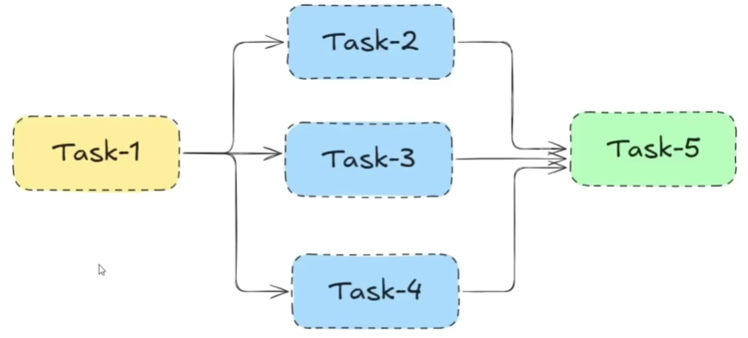
Implication: After Task 1 being accomplished, Task 2 → 4 are executed concurrently (i.e., both of them depend on Task 1). The previous tasks must be at finished state before running Task 5 or the execution stops.
Implementation
Task 1 – Extract Task
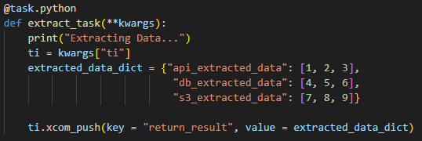
Task 2, 3 & 4 – Transform Respective Data In Dictionary (Run in parallel)
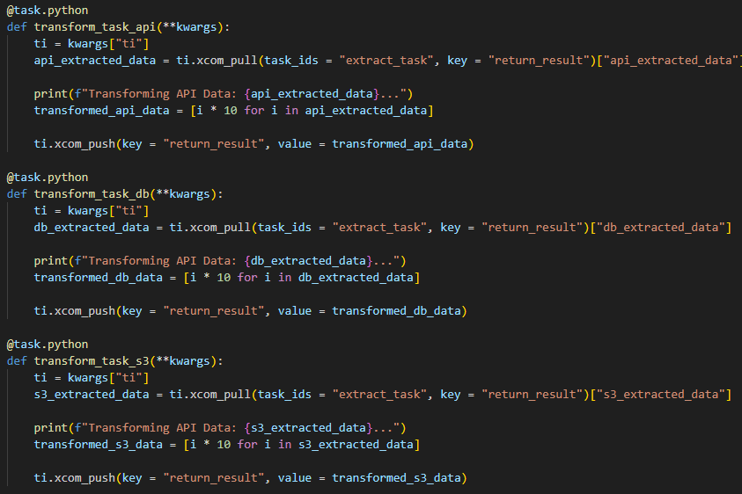
Task 5 – Load Data (Only perform after concurrent tasks all completed)
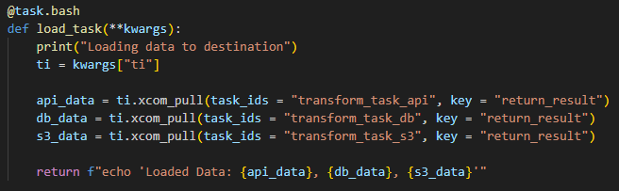
Define Dependencies
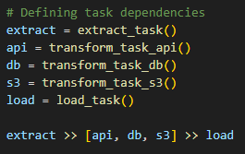
Result:
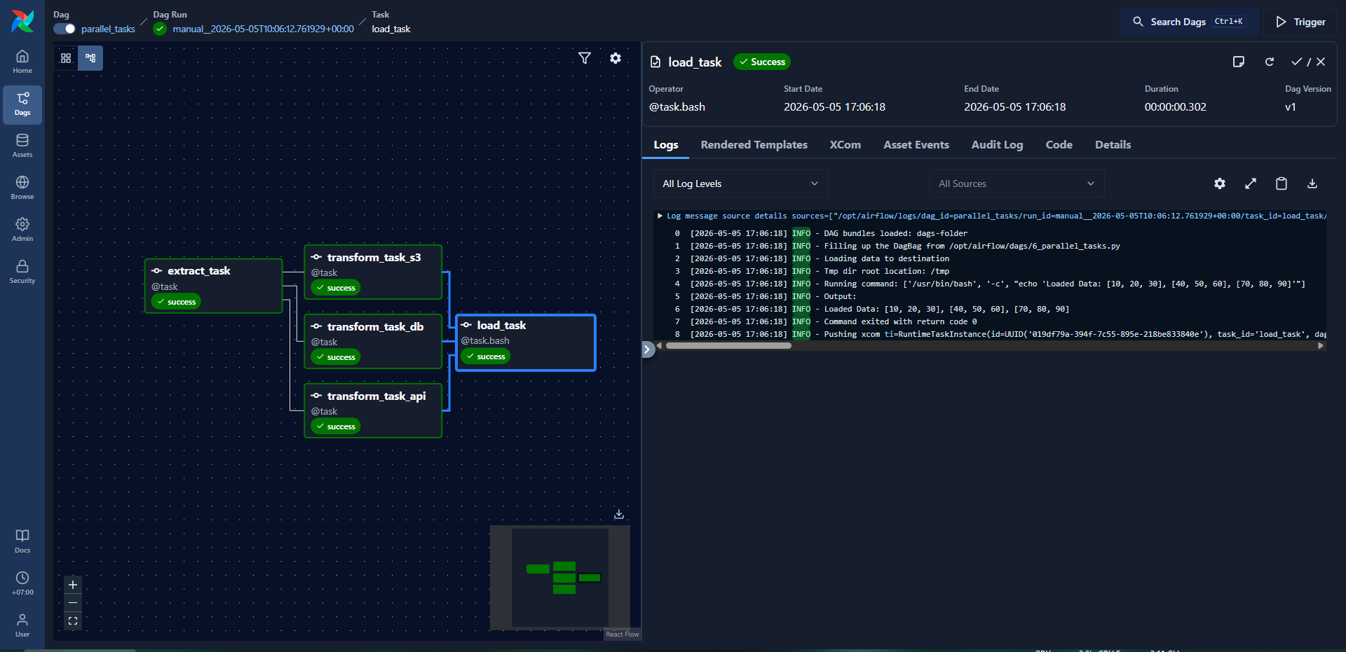
Chapter 6: Conditional Branches
Definition: Conditional branching = if-else logic in Python (let a DAG choose different execution paths at runtime)
How does it work: Airflow provides special operators
- BranchPythonOperator (classic way)
- @task.branch decorator (modern Airflow 2.X way)
The branching function must return:
- a task_id (string), or
- a list of task_ids
Those tasks will run; all others downstream are marked skipped.
Example (Conditional Branches + Parallel Tasks)
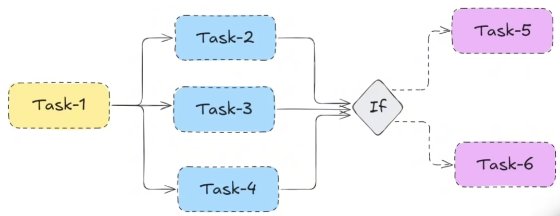
Modification from previous example (Chapter 5)
- Add weekend_flag onto dictionary – Set it as false
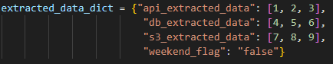
- Add extra task for if-else handling (no_load_task >< load_task)
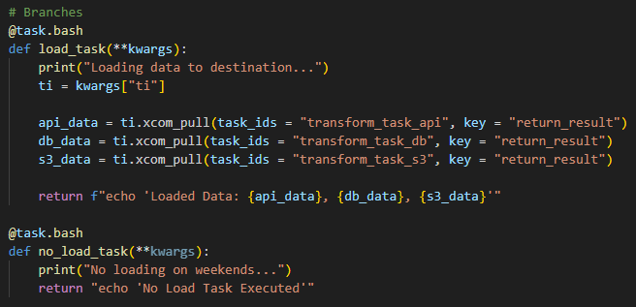
- Create the decider node
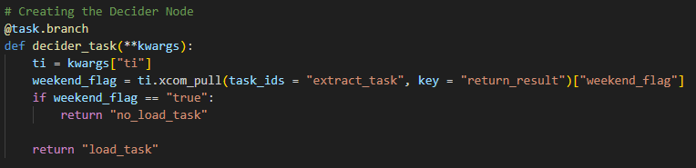
- Updated Task Dependencies
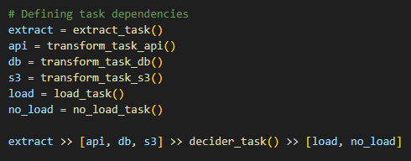
Result:
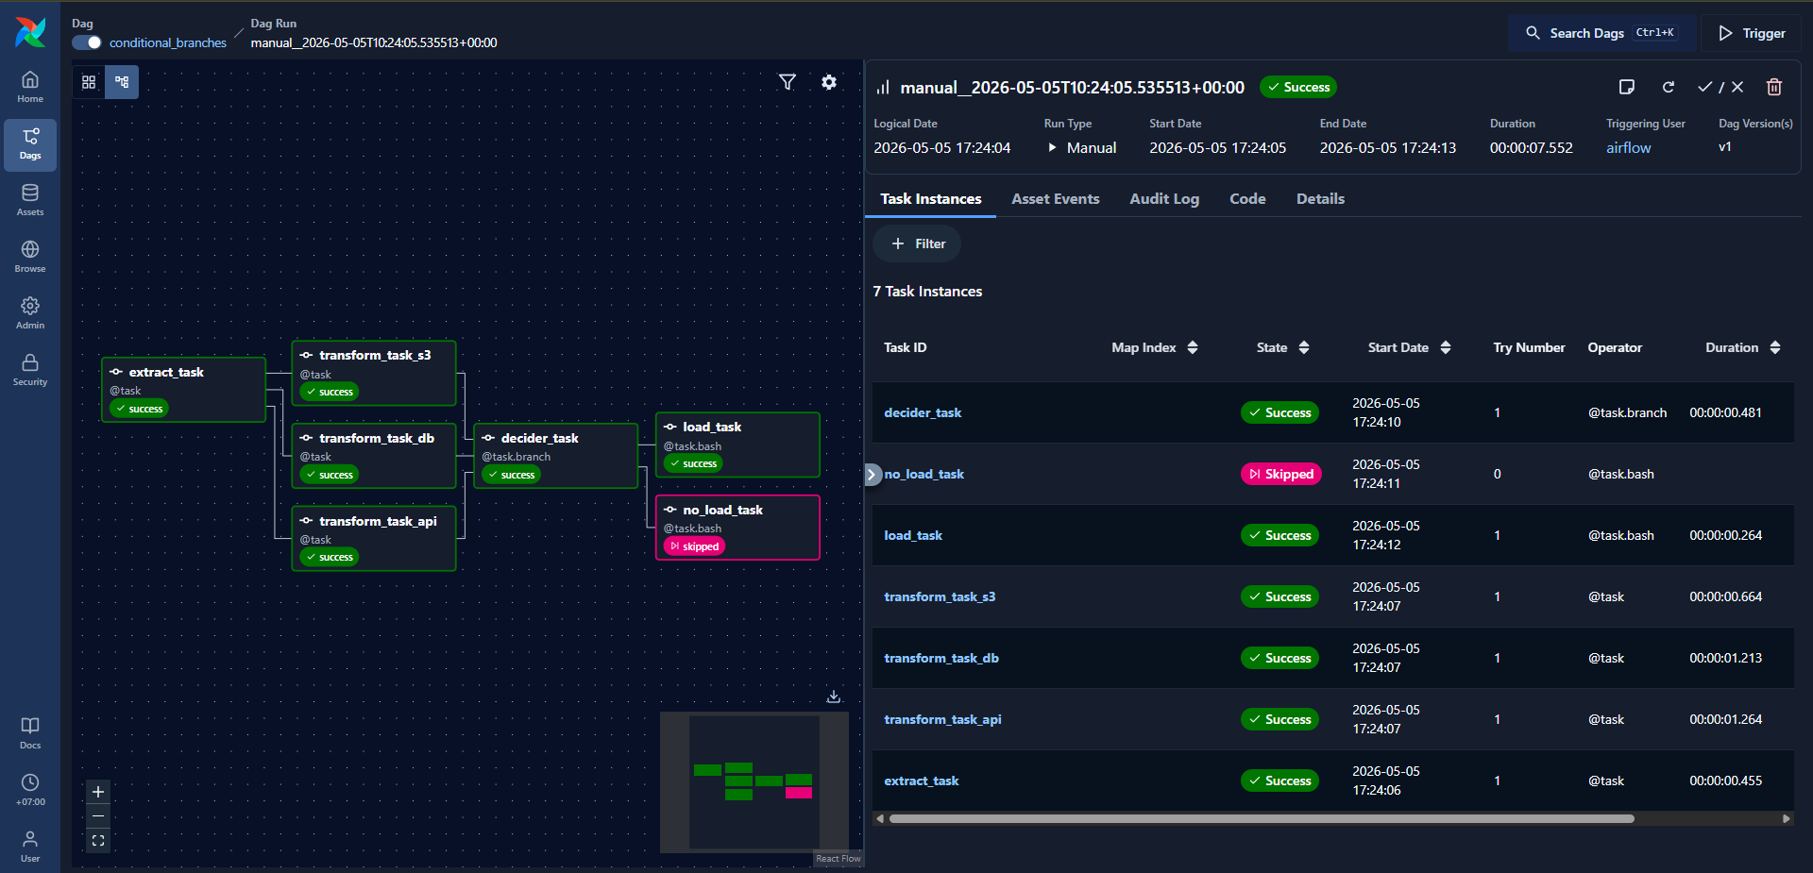
Chapter 7: Scheduling Presets
Definition: Scheduling presets = built-in shortcuts for common cron schedules in Airflow. They make it faster and less error-prone to define when your workflows should run.
Components: start_date (Required), end_date (Optional), catchup (Optional), schedule → Presets (Required)
Common Airflow Scheduling Presets
Preset | Meaning
@once | Run only once
@hourly | Every hour
@daily | Once per day (midnight)
@weekly | Once per week
@monthly | Once per month
@yearly | Once per year
@continuous | Run immediately after previous run finishes
None | No schedule (manual trigger only)
Example
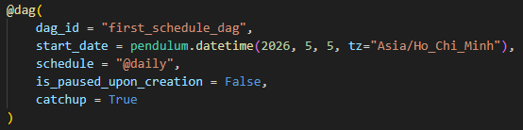
- is_paused_upon_creation: Specifies if the dag is paused when created for the first time. If the dag exists already, this flag will be ignored. If this optional parameter is not specified, the global config setting will be used.
Cron Syntax = a 5-field string that tells Airflow exactly when to run a DAG
- Cron Format
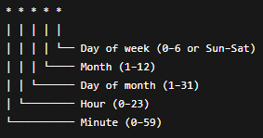
- Common Examples
Cron expression | Meaning
0 * * * * | Every hour
0 0 * * * | Every day at midnight
30 9 * * * | Every day at 09:30
0 0 * * 0 | Every Sunday
0 0 1 * * | First day of every month
*/15 * * * * | Every 15 minutes
- Worked Example
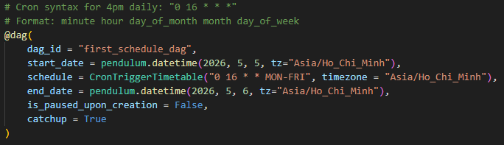
Result:
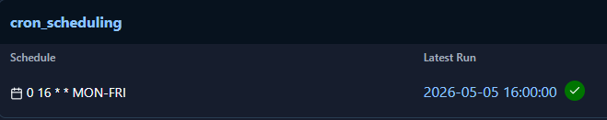
Delta Trigger = “run this DAG every X amount of time (e.g., every 03 minutes, every 2 hours)”
- How does it work?
  - Instead of schedule="0 * * * *" # cron (every hour at minute 0)
  - We use: from datetime import timedelta; schedule = timedelta(hours = 1) → “Run this DAG every 1 hour after the previous session”
- Difference between Cron VS. Delta
  - Cron (fixed clock time) – Runs at exactly: 01:00, 02:00, 03:00; Anchored to the clock
  - Delta (relative interval) – Run every 1 hour; Anchored to start date (or actual clock standing)
- Worked Example
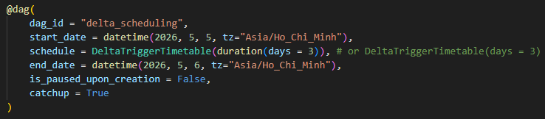
Result:
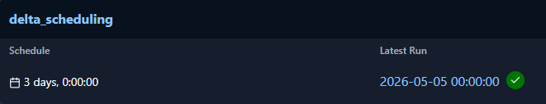
Chapter 8: Incremental Load & Jinja Template
Incremental Load: only process new or changed data since the last successful run
Incremental Load Concept:
- Load rows where updated_at > last_loaded_timestamp
- Load only today’s partition
- Load only files added since previous run
- CDC (Change Data Capture)
Airflow itself does not do incremental loading automatically. Instead, you implement the logic inside tasks / operators.
Common Pattern:
Source DB/API/File → Find last successful watermark → Query only new records → Load into warehouse → Update watermark
Jinja Templates: Airflow supports Jinja templating in many operators. Useful built-in variables:
Variable | Meaning
{{ ds }} | Execution date (YYYY-MM-DD)
{{ ts }} | Timestamp
{{ prev_ds }} | Previous execution date
{{ next_ds }} | Next execution date
{{ data_interval_start }} | Start of schedule window
{{ data_interval_end }} | End of schedule window
{{ macros.ds_add(ds, 1) }} | Add days

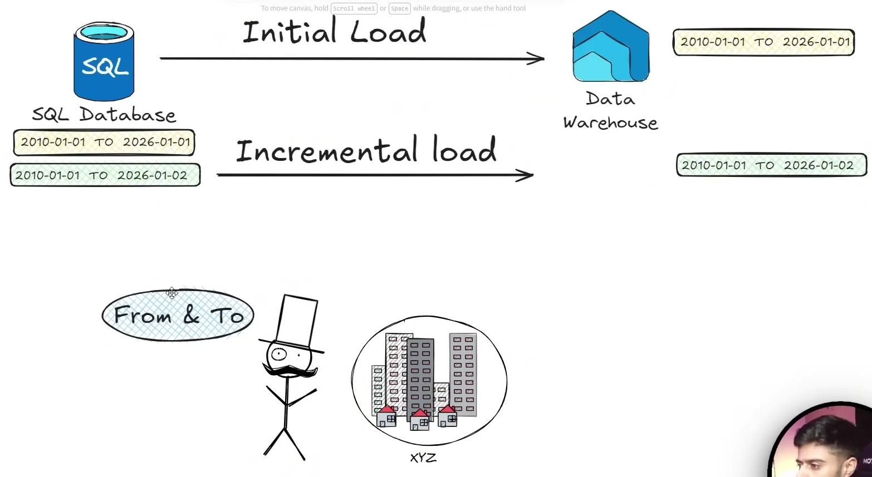
Example:
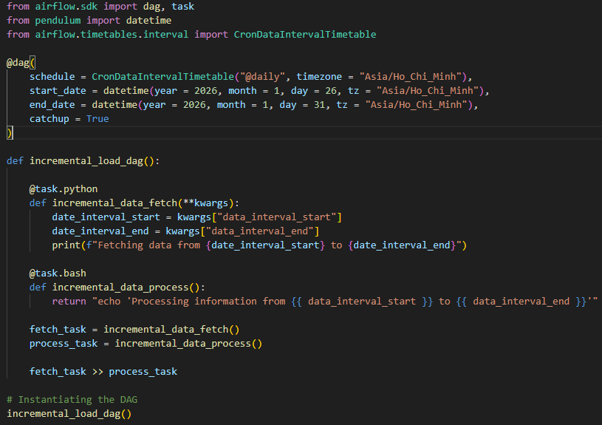
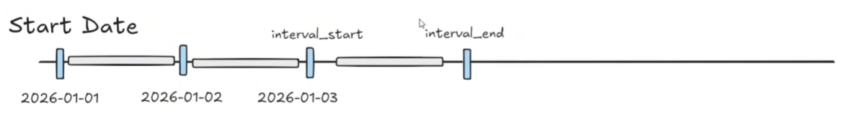
Note: Why data_interval_start/end is better?
- Older tutorials: WHERE updated_at >= ‘{{ ds }}’
- Modern Airflow: {{ data_interval_start }}, {{ data_interval_end }}
- Because:
  - Works correctly for hourly / daily schedules
  - Timezone aware
  - Aligns with scheduler windows
  - Avoids overlaps / gaps
Incremental Load Using Last Watermark (optional but production-grade)
Step 1: Store Last Loaded Timestamp
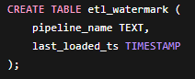
Step 2: Use it in SQL
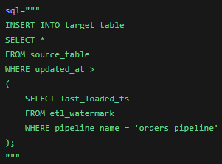
Chapter 9: Special Schedules – Events
Definition: Special schedules usually use
- Custom timetables
- Dataset events
- Event-driven scheduling
- Hybrid trigger logic
Example:
- Run only on trading days
- Run after another dataset updates
- Run on the last workday of month
- Run after file arrival
- Run every 3rd Friday
- Run after Kafka/S3/db events
Types of Event / Special Scheduling
- Cron / Time-based Scheduling
Standard Scheduling: schedule = “0 12 * * *” – Runs everyday at noon
Good for predictable intervals
- Timetable-Based Scheduling (Custom Logic)
Airflow allows custom timetable classes, which are considered as “special schedules”
You can define:
- holidays
- business days
- complex intervals
- irregular schedules
- Dataset/Event-Driven Scheduling
- Modern Airflow supports datasets.
- A DAG can start when another DAG produces a dataset.
- This is true event-driven orchestration.
Implementation

Chapter 10: Assets
Definition
Assets (called Datasets before Airflow 3.0) are a way to model data dependencies between DAGs instead of relying on cron schedules.
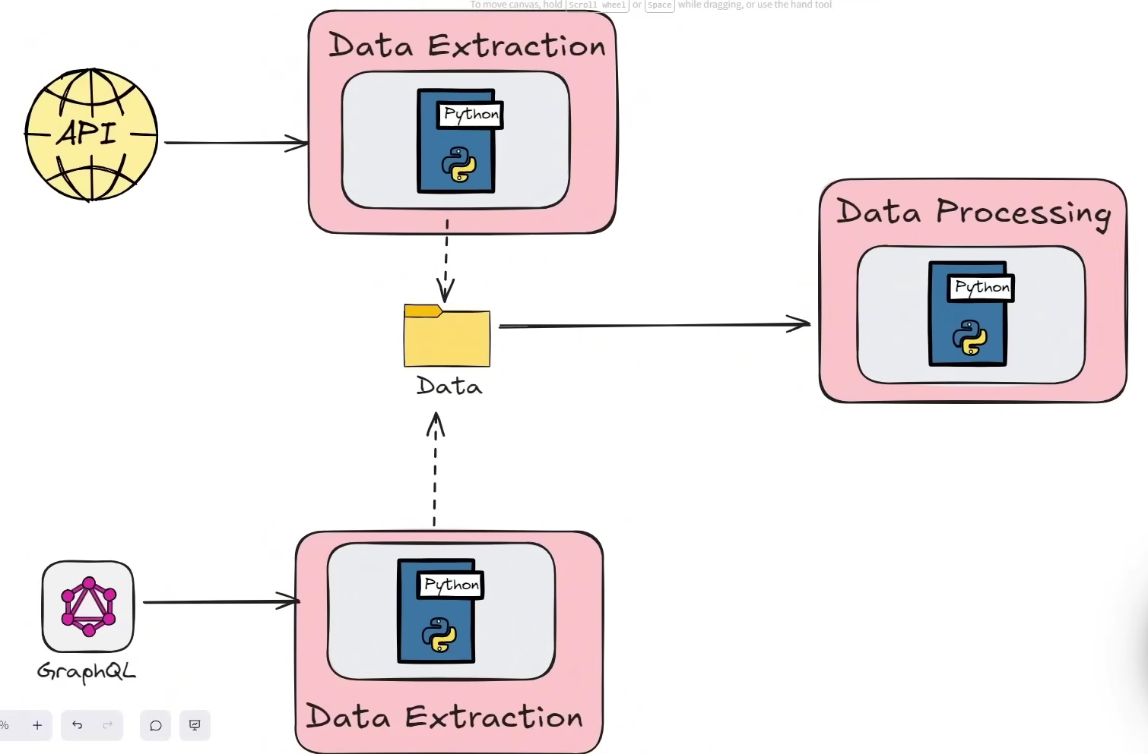
An asset represents a logical piece of data, such as:
- an S3 file
- a Snowflake table
- a Kafka topic
- a machine learning model
- a business event
When one DAG updates an asset, another DAG can automatically trigger based on that update.
Why Assets Matter
Traditional: schedule="@daily"
Asset-based scheduling: schedule=[customer_table]
This means “Run this DAG when the customer_table asset is updated”, which enables data-aware orchestration.
Core Concepts
Concept | Meaning
Asset | Logical data entity
Asset Event | Update notification
Producer | Task/DAG emitting asset
Consumer | DAG depending on asset
URI | Unique identifier
outlets | Declares produced assets
inlets | Declares consumed assets
Multiple Assets
A single task can emit multiple assets
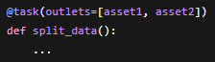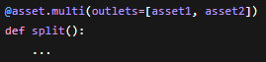
Example
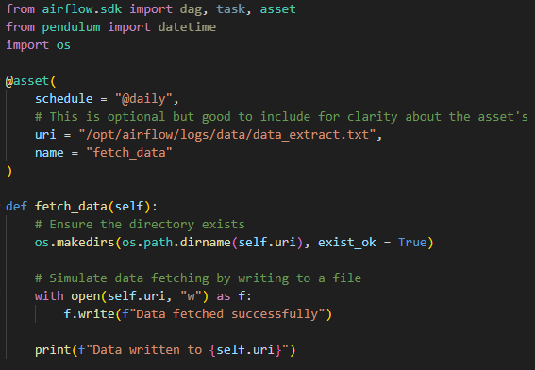
Dependent Asset
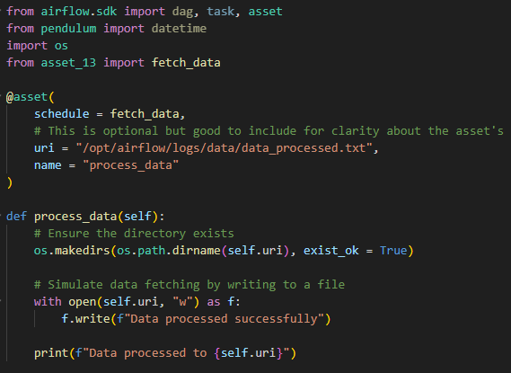
Result
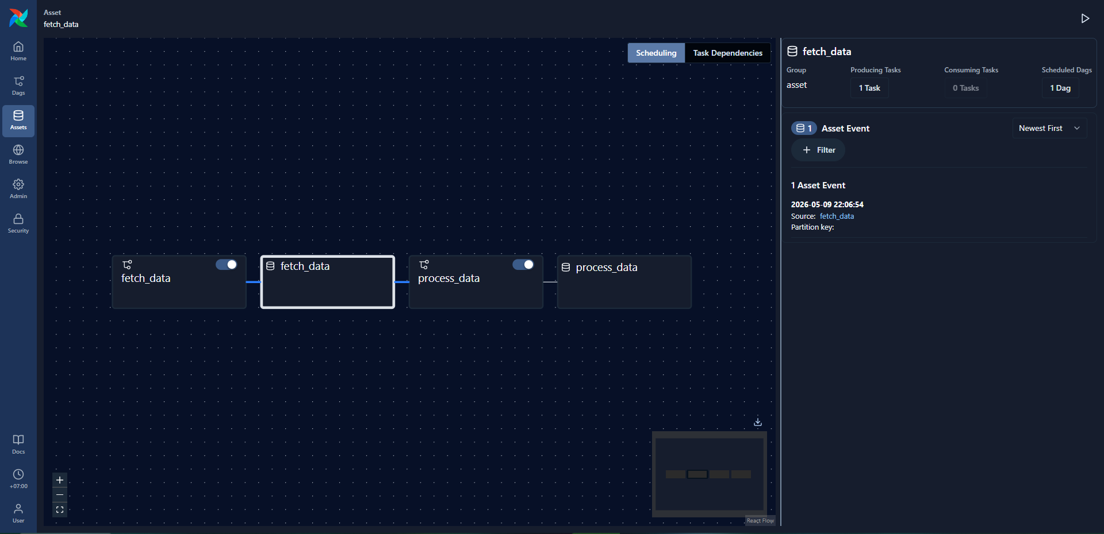
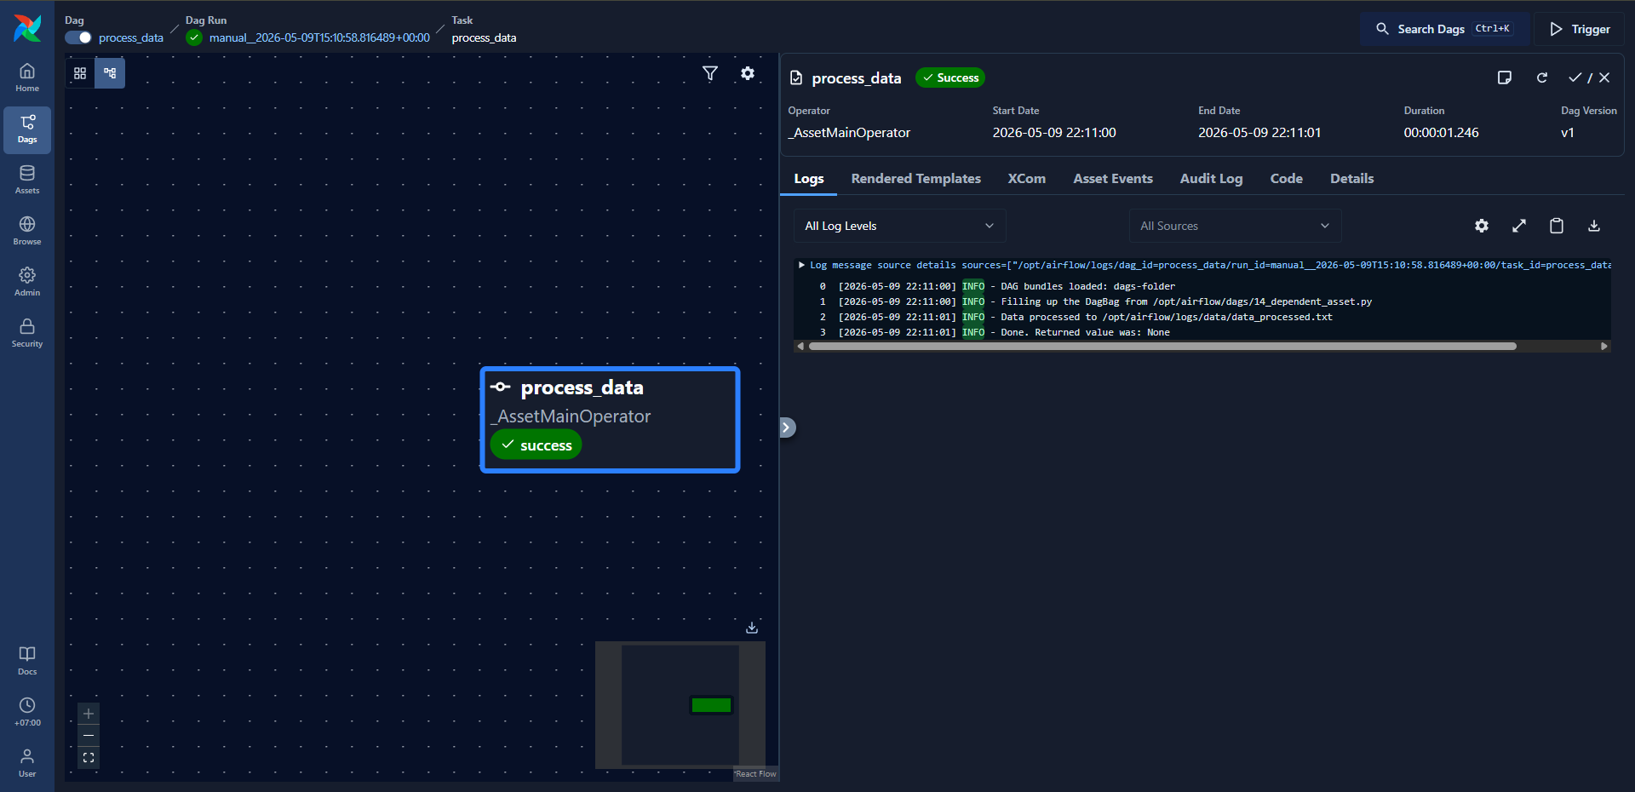
Chapter 11: Inherited DAG Orchestration
Objective: Designing DAGs so that common orchestration logic, configuration, or task patterns are reused across multiple workflows instead of duplicated.
Airflow itself does not have a first-class “DAG inheritance” feature, but teams commonly implement inheritance-like patterns in Python because DAGs are just Python objects.
Implementation:
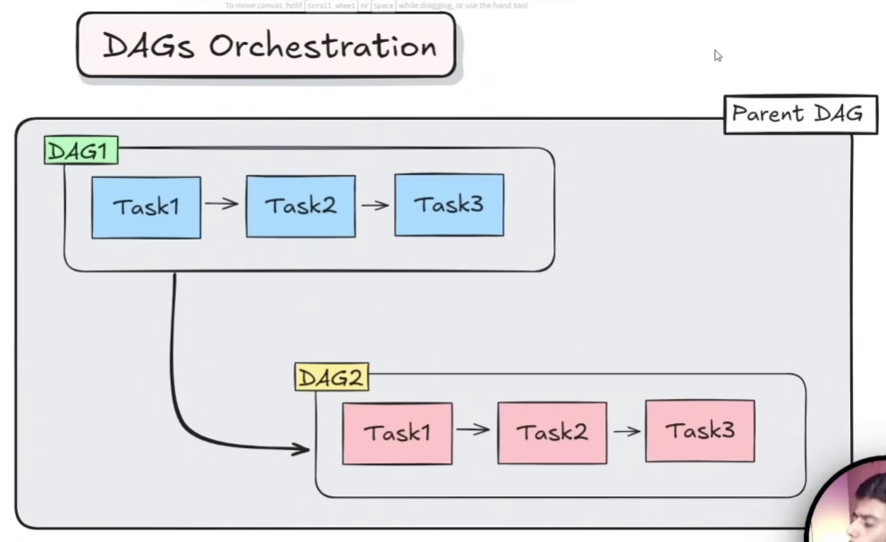
Parent Orchestrator:
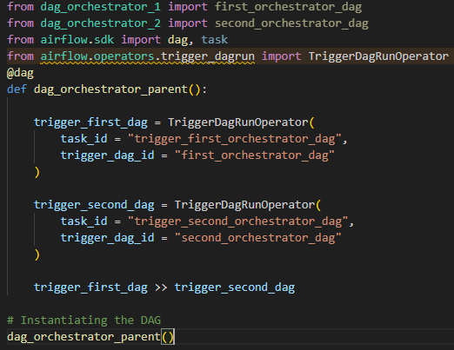
First DAG Orchestrator:
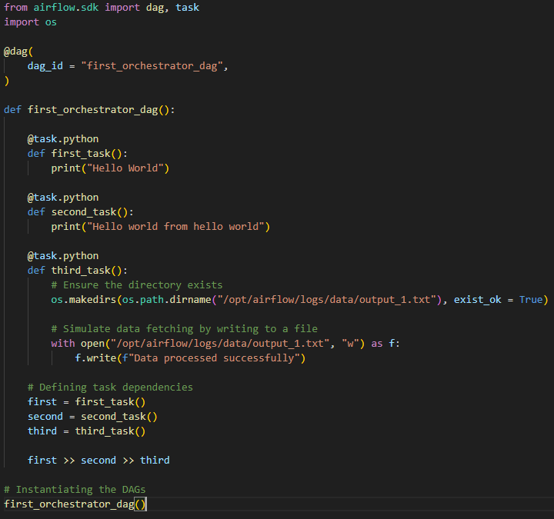
Seocnd DAG Orchestrator:
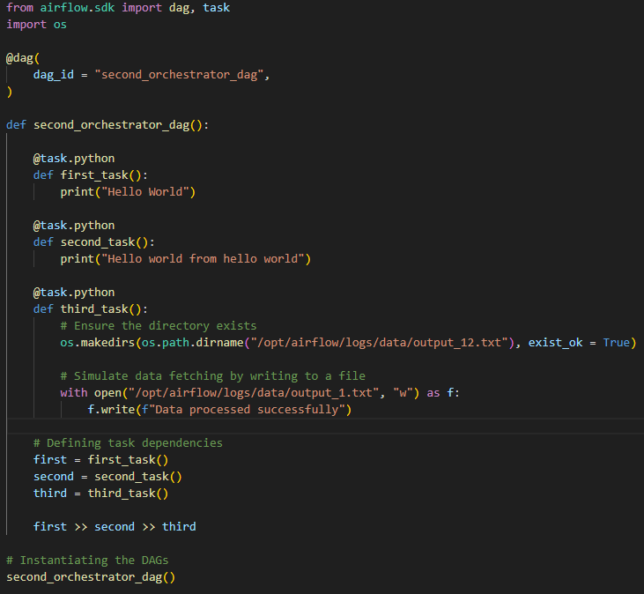
Result:
